## Music Listening Website

Submitted in partial fulfillment of the requirements of the degree of (Bachelor of Engineering)

By

**Gunjan Bharat Chopade Roll No: 12**

**Kshitij Sudhir Hirlekar Roll No: 22**

**Kaushal Sunil Pokharkar Roll No: 60**

**Narayan Babulal Sahu Roll No: 63**

Guide:

**Prof. R.N. Sanga**



**DEPARTMENT OF COMPUTER ENGINEERING KONKAN GYANPEETH COLLEGE OF ENGINEERING UNIVERSITY OF MUMBAI**

**(2022-2023)**

## CERTIFICATE

This is to certify the project entitled **“Music Listening Website”** is a bonafide work of

##### “Gunjan Chopade (12), Kshitij Hirlekar (22), Kaushal Pokharkar (60),

**Narayan Sahu (63)”** submitted to be University of Mumbai in partial fulfillment of the requirement for the award of the degree of **“T.E.”** in **“Computer Engineering”**.

Prof. R.N. Sanga Guide

Prof. S.M. Patil Dr. V. J. Pillewan

Head of Department Principal

**KONKAN GYANPEETH COLLEGE OF ENGINEERING, KARJAT.**

(Affiliated to University of Mumbai, Approved by A.I.C.T.E., New Delhi.

Konkan Gyanpeeth Shaikshanik Sankul, Vengaon Road, Dahivali, Karjat, Dist.-Raigad.410201. (M.S.)

**Department Of Computer Engineering**

## Project Report Approval

This project report entitled Title by **“Gunjan Chopade (12), Kshitij Hirlekar (22), Kaushal Pokharkar (60) and Narayan Sahu (63)”** is approved for the Third year Computer Engineering.

Examiners 1..........................................

2..........................................

Date: Place:

## Declaration

I/We declare that this written submission represents my/our ideas in my/our own words and where others' ideas or words have been included, I/We have adequately cited and referenced the original sources. I/We also declare that I/We have adhered to all principles of academic honesty and integrity and have not misrepresented or fabricated or falsified any idea/data/fact/source in my/our submission. I/We understand that any violation of the above will be cause for disciplinary action by the Institute and can also evoke penal action from the sources which have thus not been properly cited or from whom proper permission has not been taken when needed.

Gunjan Bharat Chopade -----------------------------------------

Kshitij Sudhir Hirlekar -----------------------------------------

Kaushal Sunil Pokharkar -----------------------------------------

Narayan Babulal Sahu -----------------------------------------

(Name of student/s and Roll No.) (Signature/s)

Date:

## Acknowledgement

We take this opportunity to present our votes of thanks to all those guidepost that really look like as lightening pillars to enlighten our way throughout this project that has led to successful and satisfactory completion of this study. We are really grateful to our guide Prof. R.N. Sanga for providing us with an opportunity to undertake this project providing us with all the facilities.

We would like to thank our Principal, Dr. V.J Pillewan for their constant encouragement throughout the course. We humbly thank our Head of Department, Prof. S.M. Patil for their valuable guidance and unending support despite of a very busy work schedule. The cheerful spirit they radiated all the time fueled our desire to excel in the work that we had undertaken.

Lastly, we thankful to all those, particularly the various friends, who have been instrumental in creating proper, healthy and conductive environment and including new and fresh innovative ideas for us during the project, without their help, it would have been extremely difficult for us to prepare the project in a time bound framework.

# INDEX

Abstract

List of Tables List of Figures

1. **INTRODUCTION** Introduction Existing System

Motivation Approach

Problem Statement Objectives

Scope

Proposed System

##### REVIEW OF LITERATURE

1. **REQUIREMENT ANALYSIS**

Software Requirement Hardware Requirement System Requirements

1. **DESIGN AND PLANNING** Flow chart /Process Model UML Diagrams

Data flow diagram UI Design

Gantt Chart

##### IMPLEMENTATION PLAN FOR NEXT SEMESTER

1. **FUTURE ENHANCEMENTS**
2. **APPENDICES REFERENCES**

Abstract

The continuous growing of people’s music library requires more advanced ways of computing playlists through algorithms that match tracks to the user’s preferences. Several approaches have been made to enhance the user’s listening experience; while most of them rely on the music content provided by the user, this project presents an online application that sources the audio content from publicly available resources (YouTube). A playlist generation algorithm is developed that uses only one seed track to compute a playlist of arbitrary length. For sourcing the audio content, YouTube’s track coverage is analyzed and statistics show that, in a real-life usage scenario, almost 80% of the tracks are available while the rest have rather lower popularity. The resulting application is a fully functional but feature limited online music player that can also serve as a framework for future playlist generating algorithms or other content sources. Media usage is changing rapidly these days. This processhas been ignited by several technological advances, in particular, the availability of broadband internet, the World Wide Web, affordable mass storage, and high-quality media formats, such as mp3. Many music lovers have now accumulated collections of music that have reached sizes that make it hard to maintain an overview of the data by just browsing hierarchies of folders and searching by song title or album. Search methods based on song similarity offer an alternative, allowing users to abstract from manually assigned metadata, such as, frequently imprecise or incorrect, genre information. In a context where music collections grow and change rapidly, the similarity-based organization has also the advantage of providing easy navigation and retrieval of new items, even without knowing songs by name. This opens possibilities, such as sophisticated recommendations, context-aware retrieval, and discovery of new genres and tendencies.

# List of Tables

|  |  |  |
| --- | --- | --- |
| **Figure Number** | **Title** | **Page** |
| Table 1 | Related Research Papers | 08 |

**List of Figures**

|  |  |  |
| --- | --- | --- |
| **Figure Number** | **Title** | **Page** |
| Figure 1 | Problem statement diagram | 04 |
| Figure 2 | System Flowchart of MP3 Music Player | 12 |
| Figure 3 | Class diagram(UML) | 13 |
| Figure 4 | Use case diagram(UML) | 14 |
| Figure 5 | Sequence diagram(UML) | 15 |
| Figure 6 | DFD Level 0 | 16 |
| Figure 7 | DFD Level 1 | 17 |
| Figure 8 | Gantt Chart | 18 |

# Chapter 1 INTRODUCTION

### 1.1. Introduction

Music has always been a means of entertaining people even from the earliest ages of the civilization. Historically it was produced by musicians and only available during life concerts. The technological evolution made it possible to save the music on vinyl plates, later electromagnetic charged stripes, CDs until the technology brought us to saving tracks digitally. When dealing with a huge collection of tracks, people encounter managementproblems they did not have before. So they have to develop new ways of using the music collection for their entertainment. Playlists are a good approach for saving successions of tracks that one likes. The most dominant problem of existing playlist generation mechanisms is, however, their lack of flexibility: new tracks are not automatically added, they don’t adapt to the user’s current mood etc. A new approach in dynamically organizing tracks into playlistsis on its way: companies like last.fm already suggest an algorithm of mapping songs one to each other based on their “similarities”; but how to compute these similarities? One way, that did not prove to be very productive, is to analyze the audio content of the track – its audio frequencies. This way, tracks are split in categories like “Heavy Metal” and “Blues”, but people do not like all tracks of a certain gender and these genders might be inaccurate. Another way, which is given more and more attention by researchers and companies worldwide, is computing similarities between tracks based on user input. As an example: if two users add the same two tracks to their playlists, one can deduce that these tracks are

Similar and so, also other people that pick one of them are likely to enjoy the other one as well. The music player allows a user to play various media file formats. It can be used to play audio as well as video files. The music player is a software project supporting all known media files and has the ability to play them with ease.

The project features are as follows:

* User may attach Folder to Play add various media files within it.
* User may see track lists and play desired ones accordingly.
* Supports various music formats including .mp3, WMA, WAV etc.
* Interactive GUI.
* Consists of Pause/Play/Stop Features
* Consists of a Volume controller
* The system also consists of a sound Equalizer
* It displays the media playing time with Track Bar so that user may drag the media play as needed.

### Existing System

This chapter debates the necessity of a new solution to make the world of intelligent track comparison even more accessible to the end user, followed by an approach sketch.

#### Motivation:

Several solutions already use intelligent playlists embedded in music players installed on computers. There are also online solutions, the most popular of which islast.fm, which acts as a personalized radio station that plays preferred music. On the other hand it does not allow playback of a certain track. There are also other solutions, like the genius function of iTunes or the Music Explorer; both use the user’s music collection to generate playlists. The biggest disadvantage of the latter solution is that the user can use only tracks that he/she already has on his/her PC to generate playlists. Of course this limits the power or the algorithm very much. There are already services that provide the music content (like last.fm or YouTube to name a few) so it’s a natural conclusion to try to use these service s in connection with the playlist‐generating algorithm. In order to understand the utility of such an application, just

imagine the following scenario: one enjoys listening to music while working. It is not common to store music on the company’s computer so one rather has a person al mp3 player with himself during office time. If one takes enough time to prepare ones playlists in order to fit ones current mood, it is a pretty decent solution. But what if new tracks appear that one might like? One first has to do serious research in order to find them and then go through buying them, downloading them to his/her mp3 player, updating the playlists it alreadysounds very difficult, right? Now the suggested scenario is the following: one opens a web site, types in a track that reflects ones current moo d and hits “play”. That’s it! The player chooses tracks that one likes, also plays new tracks that one did not hear before, and can go like this for hours and hours without repetition. One can go on with one’s work and in order tostop the music, one only has to hit stop or close the browser. The simplicity of the solution speaks for itself. The goal of this thesis is to analyze and implement an approach of building such a web‐based music player. The questions it has to find answers for are: How should the user interaction be designed to maximize the user satisfaction? Where to source the audi data from, while ensuring a maximum coverage? And finally, how to promote the application in order to attract as many users as possible? The different implementation possibilities are evaluated and the best solution is implemented. The logic behind the web‐based music player computes a 5 sequence of tracks based on their similarity. At the same time, user behavioral data is gathered that helps further releases to be even more user friendly. Another important aspect of the application is its extensibility. Modularity and code reusing are very important parameters of this application, as it acts as a version 1.0 for future releases. These future releases will be able to interact with the user for finding the best track video on YouTube or todetermine the mu sic preferences of users and even adapt the space to the new usage statistics.

#### Approach:

The analysis of the currently available tools to accomplish the task is one of the mostimportant steps because the ground concepts of the application should never change, regardless of its future complexity. The several possible implementations of the web service together with the balancing of computing tasks between server and client are the first parameters that have to be defined for a solid base. Also the programming language plays a crucial part in the development process, as it is shown later. The amount of callbacks to the database in favor of less memory usage is also an important aspect that is difficult to estimate from the start. In order to allow a high flexibility while still maintaining a small dataflow, the implementation of the logic is mainly on the server. The UI responsibility is fully retained by the client side as well as servicing UI requests and only notify the server of such activity. In

order to achieve the high goals that were set, the structure of the application is important to be highly modularized to allow interchanging the modules with better, more complex implementations. It is important to determine which components are possible and also easy to modularize, without introducing too much communication overhead in the interfaces. It turns out that the music content related jobs can easily be modularized, as well as the DB related jobs and the playlist computing tasks. The core of the application only needs to handle these modules and the logging task. Also the communication with the client is modularized, making it particularly easy to implement new clients running on the same service or new services to serve the same client.

### Problem Statement

This music application is an online web site for a music store. The application is a virtual showcase for everything related to a music store. The site has information regarding the latest songs, albums, and artist. An online music application offers the customers, the chance to hear performances of their favorite artists or their most liked songs.

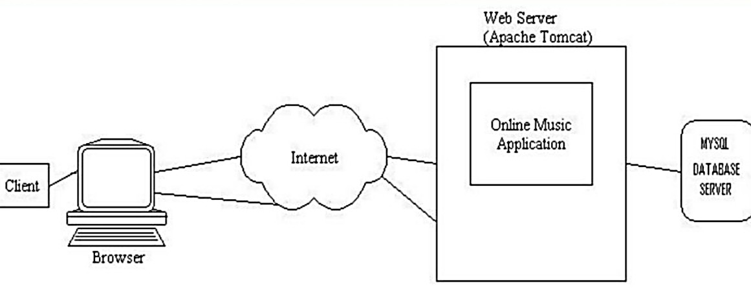

##### Figure 1: Working of Website

This Above Figure depicts the framework which we intend to implement through this web application. As illustrated by the diagram, this web application will enable any user (client) to retrieve music resource like songs or DVDs online via the internet which holds our music application. In other words, our applications connectivity with the MySQL database servers is to provide the client with his/her favorite music in his pc.

### Objective

The primary purpose of the music streaming application is to play music available in the databases of the service, compose custom playlists and suggest similar songs. The main elements of music streaming website are:

* Discovery- The central component of user engagement is the availability of the music and the ability to discover similar genres.
* Recommendations- To provide users with more relevant recommendations you need to implement a recommender engine to your music streaming app.
* Personalization and deep categorization- The music can be sorted by period, genre, performer association (solo albums of band members) or by more ephemeral characteristics such as mood (happy, sad, romantic), tone (dark, brooding, sunshiny), or pace (fast, slow, waltz) of the compositions.
* Social networking- You can apply custom playlists as promotional or educational tools. Thus, users can share playlists with friends via social media platforms.

When developing your music app, consider the following requirements for music streaming services:

* Public Performance License, issues by [ASCAP,](https://www.ascap.com/) [BMI](https://www.bmi.com/) or [SESAC](https://www.sesac.com/%23/) for the U.S. and by [PPL](https://pplprs.co.uk/) [PRS](https://pplprs.co.uk/) for U.K. services
* Diverse categorization system to tag content
* Extensive integration with social media platforms

### Scope

**1:** Deliver a single tool for collecting and accessing music data from a diverse set of sources. **2:** Deliver a set of data-driven services for estimating the current and future popularity of songs, artists and genres.

3: Deliver a set of services for enhanced audience analysis and management.

**4:** Integrate music data collection, mining, and visualization in a scalable Software-as-a- Service (SaaS) platform.

**5:** Perform large-scale pilots on three clearly defined music segments.

**6:** Develop and execute a comprehensive dissemination and exploitation plan and pave a clear path to market.

### Proposed System

When user starts the application, he can select which type of music he want to listen among various types shown on the screen. The most useful feature will be the quick search where user can search a song they want to listen. They can make their own library of songs byadding them into a playlist. User can like a song so as to make their list of favourite songs.

# Chapter 2 REVIEW OF LITERATURE

##### 1st Research Paper

With the rapid development of computer and communications technology, the mobile phone is more and more powerful. That is not just a mobile communication tool in our daily life, a variety of media applications begin to appear on cell phone, such as video calls, multimedia player, etc. In order to realize these applications, the support of a more powerful development platform is needed, so the research of Smartphone operating system and its development has become one of the most active areas.

In November 2007ˈOHA (Open Handset Alliance), which lead by Google, released a Smartphone platform - Android. Android is an open and free platform for mobile terminals which includes operating system, middleware, and user interface and application software. Android has a good development and debugging environment, provides a variety of APIs and supports a variety of common audios/ videos decoding. The openness of Android platform can not only promote the technical innovation (including the platform itself), but also help to reduce development costs, and allow manufacturers to customize the characteristic product easily. Therefore, it has a large market potential.

We designed and implemented a music player based on Android in this paper. According to the feature of mobile phone, the music player makes full use of screen to show more information. In addition to the basic functions of playback, the music player can also make music rating and display the previous and next music name of current music. The design of the player also has some significance for developing other applications on Android.

##### 2nd Research Paper

Smart mobile terminals have affected the modern people everywhere with a higher increasing trend. According to the industry data provided on the internet, the market of shopping on smart mobile terminals have reached to 34.12 billion for the 3rd season of 2013 only in China, with an increasing of 17.7 percent compared to the 2nd season of 2013, and 104% higher to the same period of 2012. Smart mobile terminals will be more likely modular and concise and using the similar platform, and under this direction, the open-source Android system will have more rapid development. Our interactive music application design is based on the Android smart phone system, solves with the resource limitation problem for ordinary mobile phones in the music player. Our paper gives a design and implementation of the music player system based on android mobile. Since the ordinary mobile phone music player is limited to the mobile phone memory size, it can only play

inherent audio files in the smart phone, and new audio files can only be re download on the computer. Our music player on Android phones do not need to consider these issues, and it can always search the local phone files you want to update, and the sound quality is better than ordinary music player as it is faster. Besides, Android platform is the first complete, open and free mobile platform that allows developers to have greater freedom in their development process, our music player may have a certain commercial values for data collection.

##### 3rd Research Paper

In the past few years, the percentage of Thai people who have stress has raised at a higher rate. This is because of several reasons such as debts, higher product price, bad economy, high living expenses, etc. In 2017, the Thai department of mental health collects information from Telephone service for mental health counsellors and presents that the stress of Thai people tended to increase. The number of phone calls is more than 30,000 calls which are twice in 2014.

Stress can be eliminated in various ways; for example, workouts, watching movies, meditation, and listening to music. Many pieces of research state that music can assist people to reduce stress and be more focus. Unfortunately, listening to music may be unhelpful if the music does not suit the current emotion of the listener. Thus, to reduce stress, the music with the proper mood should be chosen. Furthermore, although there are many music player applications, there is no application which is able to select songs based on the user emotion. To solve these limitations, this paper proposes a mobile music player application which is able to recommend songs based on the user emotion. To classify the user emotion, the proposed application applies both the heart rate and face image. When the application receives a user heart rate from a smart band or a face image from a mobile camera, it analyses what the user emotion is. Then, it suggests songs whose moods are relevant to that user emotion. The user and song emotions in this paper are divided into four types; namely, neutral, happy, sad and angry. The experimental results present that detecting the happy emotion is the most precise with around 98%, while the accuracy of the sad mood detection is the lowest with 40%.

**Table 1: Related Research Papers**

|  |  |  |  |  |
| --- | --- | --- | --- | --- |
| Sr. no | Title of the paper  and year of publication | Author name | Methodology | Limitation |
| 1) | Development and Research of Music Player  Application (Year of publication is 2010) | 1)Yong-Cai Pan 2)Wen-chao Liu 3)Xiao Li | Phase 1: Discovery and business analysis  Phase 2: Plan out the app features  Phase 3: Design and development | 1. Customer interaction is less. 2. Design phase once implemented it is difficult to change   again |
| 2) | Emotion-Based  Music Player(Year | 1. KrittrinChankuptarat 2. RaphatsakSriwatanaworachai | Phase1:Communication  Phase2:Planning | 1)It is very  rigid |

|  |  |  |  |  |
| --- | --- | --- | --- | --- |
|  | of publication is 2019) | 3)SupannadaChotipant | Phase3:Modelling Phase4:Coding  Phase5:Testing | 2)Small team. 3)Costly |
| 3) | Interactive music player design on smart mobile terminal based on Android(Year of publication 2014) | 1)Dandan He 2)Lijuan Wang 3)Can Wang | Phase 1:Requirement gathering  Phase 2 :Planning Phase 3:Quick design Phase 4: Construct prototype  Phase 5:Ask customer if he likes it then implement or create new prototype again Phase  6:Implementation | 1)Costly 2)More time consuming |

# Chapter 3 REQUIREMENT ANALYSIS

**Software Requirment** Editor for code - vscode Graphics editor – gimps

Languages – html, css, JavaScript

Web browser – chrome, internet explorerdatabase –mysql

**Hardware Requirement** Processor: P|||700MHZ RAM: 64 MB RAM

Hard Disk: 20 GB HHD

##### Supported Devices for Music Website

IOS - IOS 13 or above

Android - Android OS 5.0 or above MAC - OS X 10.13 or above Windows - Windows 7 or above

##### Domain

Website Development

# Chapter 4 DESIGN AND PLANNING

**FLOW CHART/PROCESS MODEL**

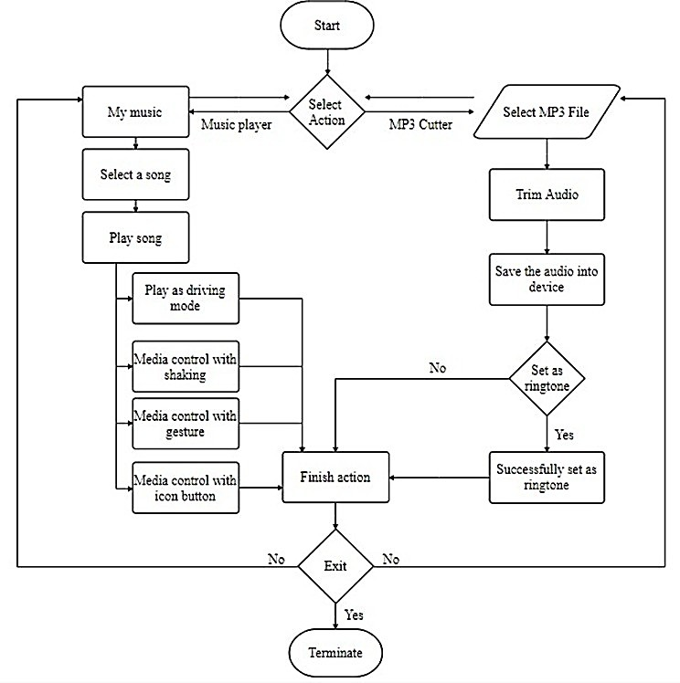

##### Figure 2 System Flowchart of MP3 Music Player

Figure 1-1 shows the system flowchart of the mp3 music player. When the user starts the application, they can select two types of the main action of the application. The main action is divided into the music player and mp3 cutter. The first case is a music player, where users can select a song they want to listen to under the "My music"fragment and click it to play. In the music playing interface,users have a variety of options for action which are playing as driver mode, mediacontrol with shaking, media control with the gesture, media control with the icon button. The second case is an mp3cutter. After the user selects the song he or she wants to trim, the application will start to trim the music and save it to the mobile device. At this point, the application will ask the user if they want to set the trimmed audio to ringtone and then finish the action. After the completion of the action, the user can choose whether to exit the application or not, if "no" back to select action interface, if "yes" terminate the application.

# UML DIAGRAMS

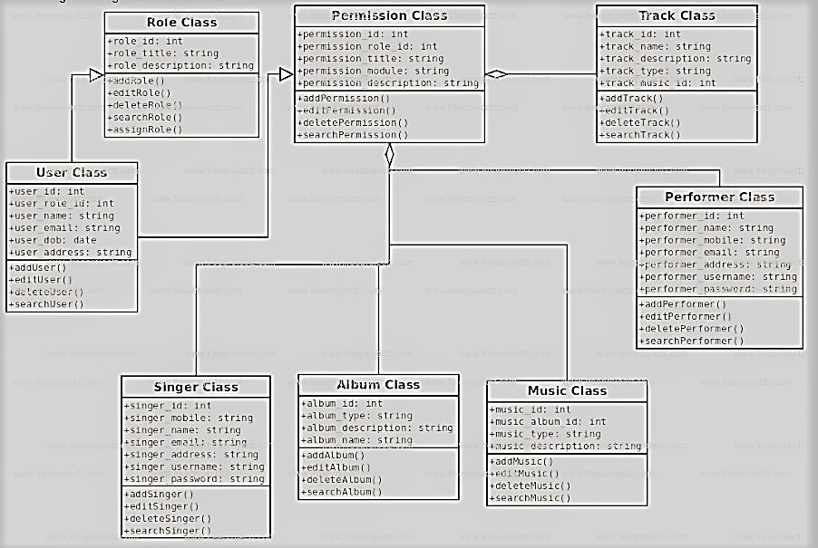

##### Figure 3: Class diagram

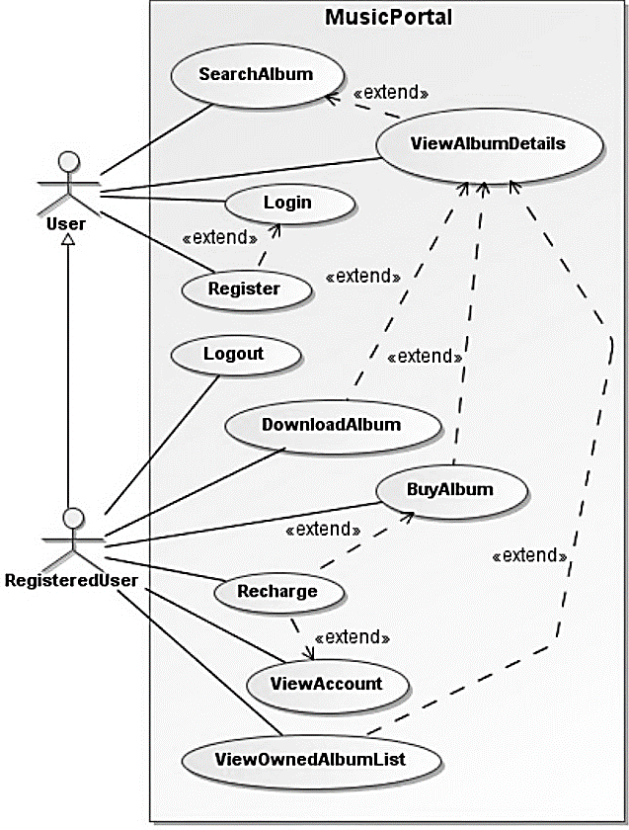

**Figure 4: Use Case Diagram**

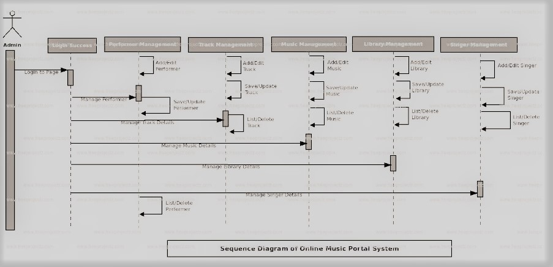

**Figure 5: Sequence Diagram**

# DATA FLOW DIAGRAMS

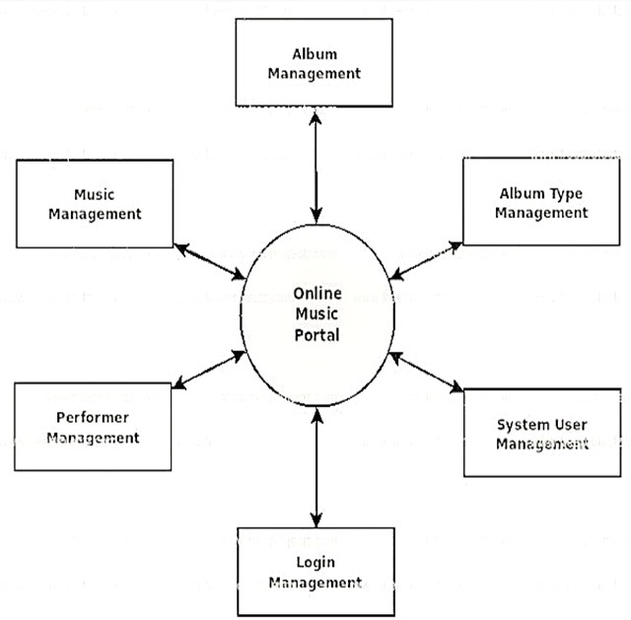

##### Figure 6: DFD LEVEL 0

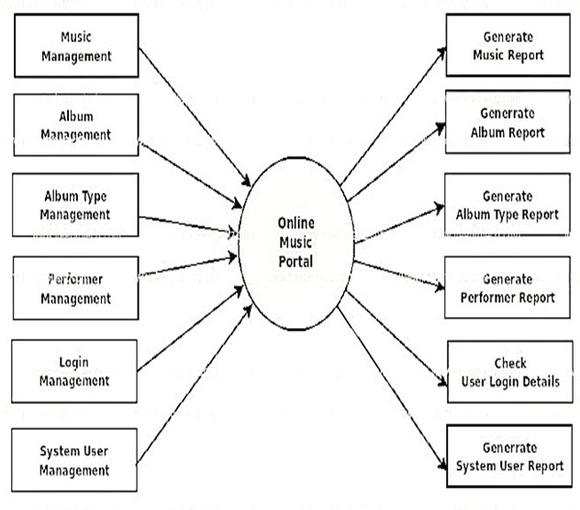

**Figure 7: DFD LEVEL 1**

# GANTT CHART

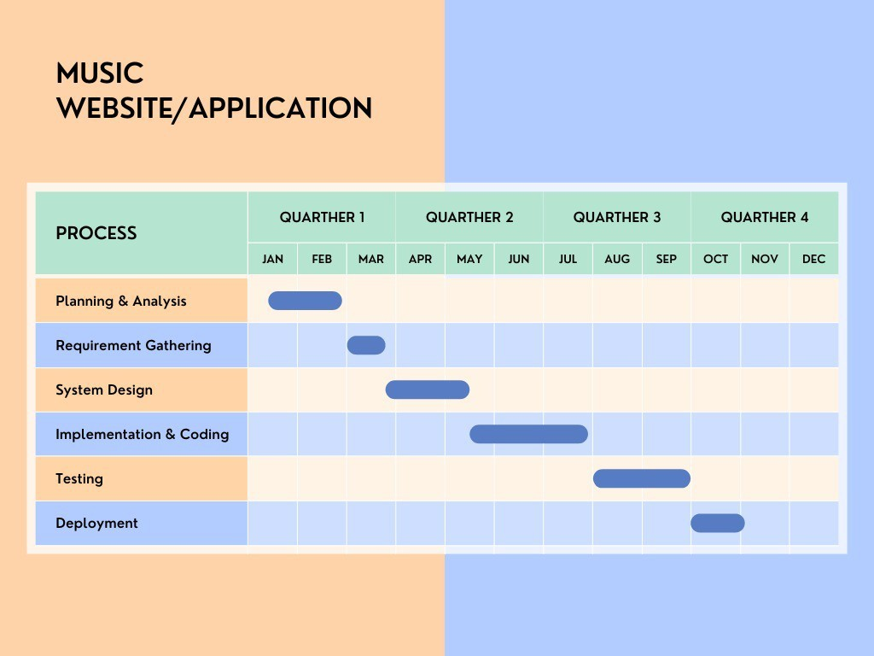

**Figure 8: Gantt Chart**

# Chapter 5

**IMPLEMENTATION PLAN FOR NEXT SEMESTER**

### The project covers the following Implementations:

##### Login, View all Songs Request

* + **Searching the Catalog:** In Online Music Website, the words entered by the visitor are searched for in the song’s names and descriptions.
  + **Handling Customer Accounts:** In Customer account system, details such as credit card numbers are stored in database so that customers don’t have to retype thisinformation each time they place an order.
  + **Making Song Recommendations:** One of the most important advantage of Online Music Website is the capability to customize the web site for each visitor based on his or her preferences, or based on data gathered from other visitor with similar preferences. In Song recommendation system, additional songs are suggested to an individual visitor in a clever way.

##### Upload/delete Songs

* + **Track song request history**

# Chapter 6 FUTURE ENHANCEMENTS

* Enhanced interactivity, allowing users to open song playlist when they swipe up from the music playing interface.
* Implement of the in-app download of songs, rather than the current use of a specific website as a hyperlink.
* Refactoring code, rebuild the coding structure to make the coding look cleaner, easier to understand and perform efficiently.
* Cross-platform, running the app on IOS, not only Android.

# References

##### Research Papers:

1. Yong-Cai Pan, Wen-chao Liu, Xiao Li, Development and Research of music player Application, (2010).
2. Dandan He, Lijuan Wang, Can Wang, Interactive music player design on smart mobile terminal based on Android, (2014).
3. Krittrin Chankuptarat, Raphatsak Sriwatanaworachai, Supannada Chotipant, Emotion- Based Music Player, (2019).
4. Bossard, L,. Pancho The Mobile Music Explorer. Zürich: DCG.TIK.EE.ETZH.CH, (2008).

##### Links:

1. https[://w](http://www.dummies.com/web-design-development/site-development/how-to-addsound-to-)ww.[dummies.com/web-design-development/site-development/how-to-addsound-](http://www.dummies.com/web-design-development/site-development/how-to-addsound-to-) [to-](http://www.dummies.com/web-design-development/site-development/how-to-addsound-to-)your-web-site-using-html
2. <https://nevonprojects.com/media-player-project>
3. [https://www.dummies.com/web-design-development/site-development/how-to-addsound-](https://www.dummies.com/web-design-development/site-development/how-to-addsound-to-your-web-site-using-html) [to- your-web-site-using-html](https://www.dummies.com/web-design-development/site-development/how-to-addsound-to-your-web-site-using-html)
4. <https://www.egrappler.com/wonderful-javascript-audio-libraries-for-developers>
5. <https://nevonprojects.com/media-player-project>
6. <https://pub.tik.ee.ethz.ch/students/2009-FS/SA-2009-10>
7. Bossard, L,. Pancho The Mobile Music Explorer. Zürich: DCG.TIK.EE.ETZH.CH, (2008).